Student name: Nguyen Tuan Khoi Le
Student ID: 226531772

SIT225: Data Capture Technologies

Activity 1.1: Arduino Blink

Welcome to Arduino!

Arduino is an electronic prototyping platform. Different types of sensors & actuators can be attached to Arduino boards to create our own sensing-thinking-acting systems.
Throughout this unit, we will use Arduino to create different sensing devices, and to retrieve the collected sensor data.
In this task, we will try out an introductory exercise, to learn the basic concepts of Arduino.

Hardware Required
- Arduino Board with in-built LED
- USB cable

Software Required
Arduino programming environment

Pre-requisites: You must do the following before this task
Unit site weekly materials
Active learning sessions require reading material and/or videos available in the unit site, which you must read/view BEFORE you start the lab. If you are on-campus, this means that we expect you to have gone through these materials when you join active learning sessions.

Why should you read/watch pre-lab materials?
These materials will help you understand the background which the lab tasks require. Students come to university from diverse backgrounds. Some of you may be familiar with the background information, some of you may not. When you come to the lab prepared, you’re already equipped with confidence and will be able to participate in activities better. Ultimately, class time will be much more productive, dynamic, and fun for everyone.

Here are the pre-lab materials for our first task:
- Watch TED Talk: https://www.youtube.com/watch?v=UoBUXOOdLXY (~15 minutes)
- Read Arduino tutorial: https://www.dummies.com/article/technology/computers/hardware/arduino/how-to-complete-your-first-arduino-sketch-164747)
- Read this task sheet from beginning to end.

Task Objective
“We have an Arduino board with an in-built LED light. We need the LED light to be turned on and off continuously, every one second.”

Activity Submission Details
Answer the questions below in this word document and other activities in this activity sheet to create a PDF and submit to OnTrack as described in this week’s OnTrack task. PDFs of this activity sheet and OnTrack task need to be merged for submission in the OnTrack portal.

Q1: The TED talk given under the Pre-Lab materials, shows how Arduino is being used for interesting projects to capture data from the environment, process it, and use it to carry out useful actions.
Fill the given table below to answer the following:

What are three projects that use captured data as given in the TED talk? What data do they capture? What sensors do you think they could use to capture this data?
Project name | Data captured | Sensors to capture the data

Q2: Consider the given Task Objective. Think about how this simple system can be decomposed to ‘Sense-Think-Act’?
  - What is the ‘sensing’ requirement in this system, if any?
  - What is the ‘thinking’ requirement in this system, if any?
  - What is the ‘acting’ requirement in this system, if any?

Q3: Please refer to the provided ‘Arduino Blink Activity Sheet’ and follow the steps.
- In Arduino-speak, what is a “sketch”?
- setup() and loop() are key Arduino constructs. These are required in every Arduino sketch.
  - Which of the above two, runs once at the very beginning of your program and never again (unless you reset or upload new code)?
  - Which of the above two, is used to continuously run code over and over again?
- What does pinMode() do?
Hint: http://arduino.cc/en/Reference/HomePage
- What is a comment?
- What does the following line of code do:
delay(x);
Hint: http://arduino.cc/en/Reference/HomePage
- There is something you need to check before uploading your sketch. What is this?

Q4: How can you test the Blink program to make sure it is working as given in the Task Objective?

Activity 1.2: Write Arduino data to serial communication port
Now you can blink Arduino’s built-in LED, it is time to talk to outside Arduino-world, your computer which connects the Arduino board using a USB cable. Arduino IDE shows what you write to the serial port.

Hardware Required
- Arduino Board with in-built LED
- USB cable

Software Required
Arduino programming environment

Steps:

Steps | Actions
1 | Identify the port through which Arduino is connected to your computer. You can find it in Arduino IDE Tools menu. Write Arduino sketch (or download from https://github.com/deakin-deep-dreamer/sit225/blob/main/week_1/sketch_blink.ino ), which look like below, in Arduino IDE, deploy in your board and observe the output in IDE’s serial monitor.  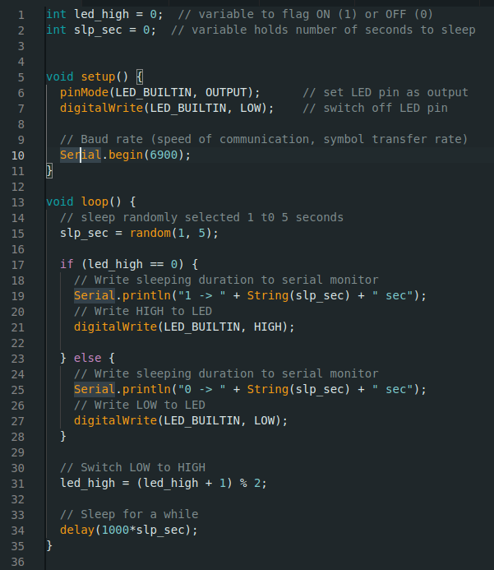  Question: Screenshot the serial monitor output and paste the image here.  Answer: <Your answer>
2 | Question: Observe the use of “Serial” such as functions Serial.begin() in setup and Serial.println() in loop. Describe what these functions are doing with respect to the serial monitor output you have attached above.  Answer: <Your answer>
3 | Question: If Arduino transfers data at 4800 bits per second (baud rate) and you're sending 12 bytes of data, how long does it take to send over this information?  Answer: <Your answer>

Activity 1.3: Arduino talks to Python
To listen to what Arduino sends, there will be a Python program running and keep listening to the same port where Arduino is writing data to receive it.

Hardware Required
- Arduino Board with in-built LED
- USB cable

Software Required
Arduino programming environment
Python 3.0 (Follow Python installation manual in unit site)

Steps:
Steps | Actions
1 | Write Arduino sketch (or download from https://github.com/deakin-deep-dreamer/sit225/blob/main/week_1/sketch_serial_comm.ino ) which looks like below. Open in Arduino IDE. Study the code. Upload the code to Arduino board and observe output in Arduino IDE serial monitor.  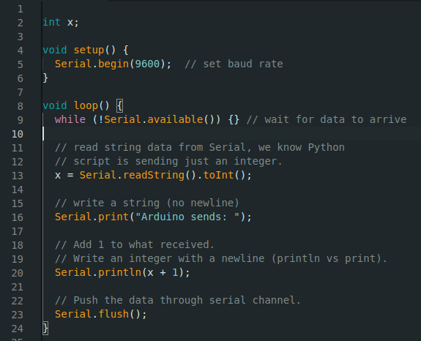  Question: Do you see any output in serial monitor? If not, then why?  Answer: <Your answer>
2 | Write Python code as below (or download from https://github.com/deakin-deep-dreamer/sit225/blob/main/week_1/serial_comm_script.py ) and save it to a file serial_comm_script.py.  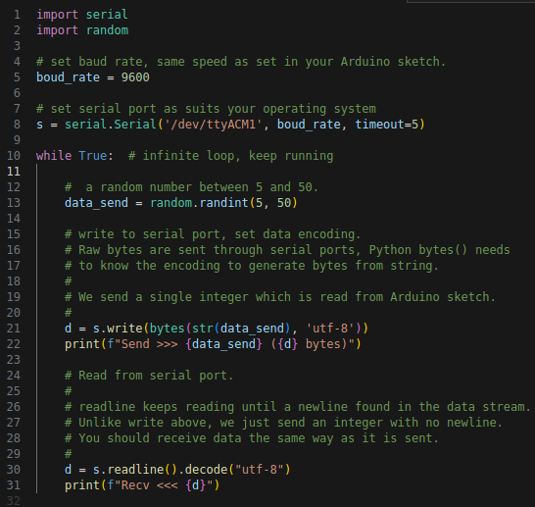  Run the Python file from command line using command:  $ python serial_comm_script.py  Question: Run Python script in command line, does the script run or do you receive any error? If there is an error, analyse the error message and identify what went wrong.  Answer: <Your answer>
3 | Question: Following the above step 2, do you think Arduino IDE is keeping the serial communication port busy talking to Arduino board? Now try to close the Arduino IDE and repeat step 2 above to run the Python script. Do previous errors show up again? If not, Python script should have print messages in the command line. Take the screenshot of the Python script output and paste here.  Answer: <Your answer>
4 | Question: Observe the Python script output and describe the communication protocol used between Arduino sketch and Python script.  Answer: <Your answer>

